To Referees of Smithsonian Fellowship Applicants:

The Smithsonian Institution offers fellowships to provide opportunities for graduate students and scholars to conduct research at the Institution, in association with members of its research staff. You are being asked by an applicant for a Smithsonian Fellowship to serve as a referee and to evaluate the enclosed proposal.

Please provide an evaluation of the proposal, considering the scholarly merit of the proposed research and the likelihood of the applicant conducting it successfully at the Smithsonian. We also solicit your comments regarding the applicant's ability and his or her potential contribution to the field. In addition, we ask that you disclose any perceived conflict of interest in providing a reference for this applicant.

All reference letters will be considered confidential, and the contents will not be revealed to the applicant unless confidentiality has been specifically waived by the referee. Reference letters requests will come in email form from solaa_sc@si.edu (generated by the applicant). Please check your junk/spam folders as many systems direct these emails to those folders. You will be able to upload your letter directly in the SOLAA system.

Please submit your letter in sufficient time for the applicant to meet the deadline date of October 15, 2024.

The application, consisting of the proposal, academic records, and two supporting letters, will be reviewed by members of the Smithsonian's research staff. Applications will be evaluated on the basis of the proposal’s merit, the applicant’s ability to carry out the proposed research and study, demonstrated commitment to diversity and inclusion, and the extent to which the Smithsonian, through its research staff members and resources, could contribute to the research and professional goals of the fellow.

Your careful assessment of this application will help us to maintain high standards in our fellowship programs. We appreciate your cooperation.

Sincerely,

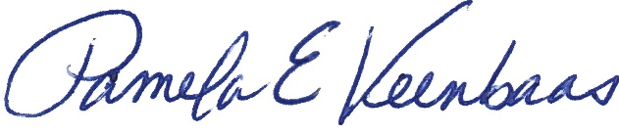

Pamela E. Veenbaas

Interim Director